Федеральное государственное образовательное бюджетное

учреждение высшего образования

**«Финансовый университет при Правительстве Российской Федерации»**

**(Финансовый университет)**

Колледж информатики и программирования

Специальность: Обеспечение информационной безопасности автоматизированных систем

**ОТЧЕТ**

ПО УЧЕБНОЙ ПРАКТИКЕ L8  
*«Обучение графическому программированию на assembler»*

Профессиональный модуль: Машинно-ориентированное программирование в защите информации

Выполнил:

обучающийся учебной группы   
№3ОИБАС-818

Д.А. Крючков

*(подпись) (И.О. Фамилия)*

Руководитель практики от колледжа:

И.В. Сибирев

*(И.О. Фамилия)*

*(оценка) (подпись)*

1. **Настраиваем отладчика**

Создаем файл OPENGL2.ASM и OPENGL_Start, затем открываем их через NotePad++.

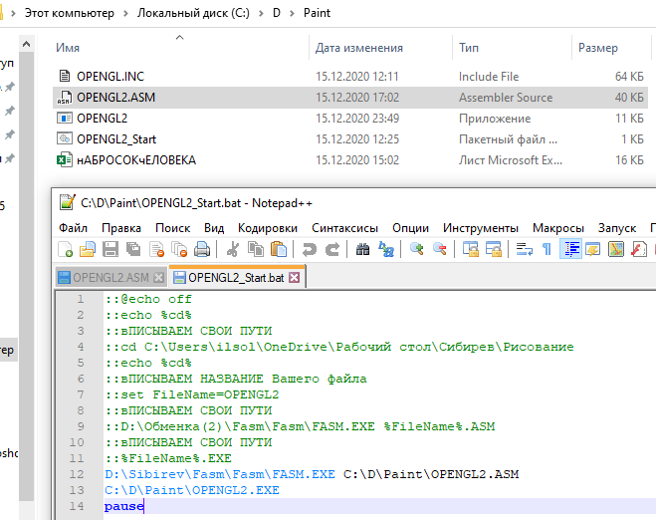

В файле OPENGL2.ASM в первой строчке указываем путь к Fasm.exe и путь к нашему файлу OPENGL2.ASM.

Во второй строчке указываем путь, где необходимо создать EXE файл для запуска программы.

1. **Далее открываем файл OPENGL2.ASM**

В папку с FASM закидываем скачанный файл OPENGL.INC и прописываем пути.

В первой строчке пишем путь к WIN64A.INC. Во второй строчке пишем путь до OPENGL.INC.

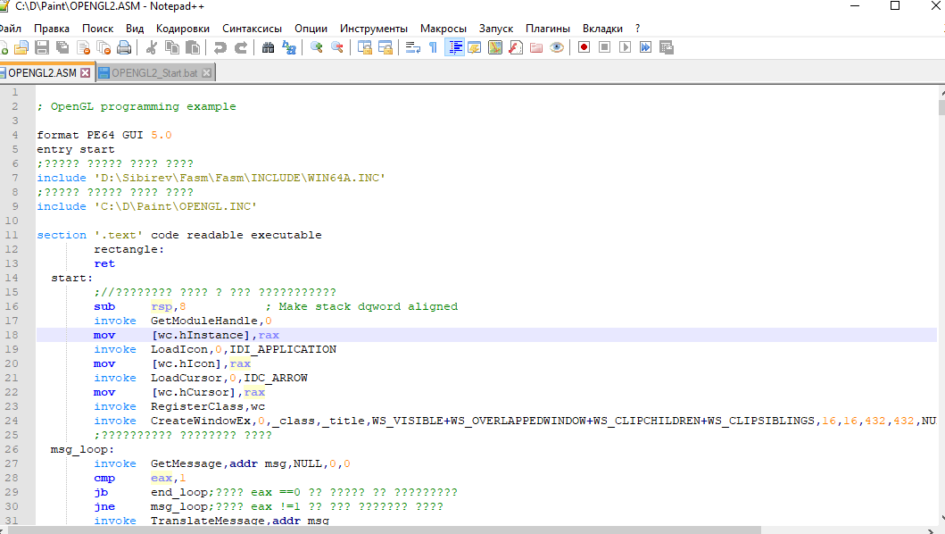

1. **Запуск отладчика мы настроили, дальше переходим к самому программному рисованию**

Открываем EXCEL файл, я назвал его «Координаты Елки».

Рисуем в таблице нашей Елки, путем присваивания ячейке значения «1», где необходимо закрасить.

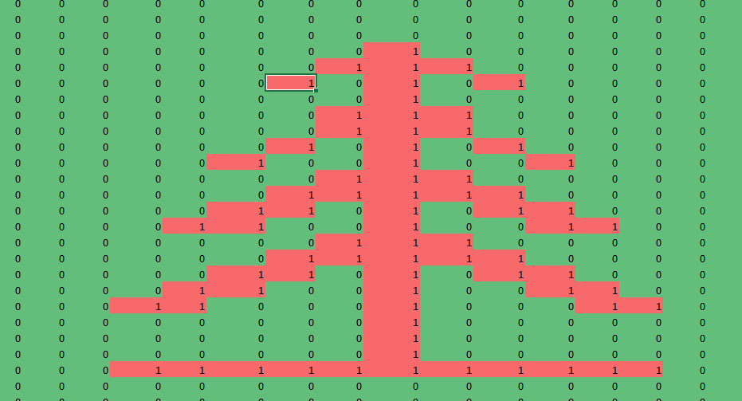

У меня получился вот такая елка. Сверху и слева мы имеем координаты, для масштабирования изображения делим координаты на 0.5.

1. **Затем переходим к файлу OPENGL2.ASM.**

В итоге мы получаем следующий вывод.

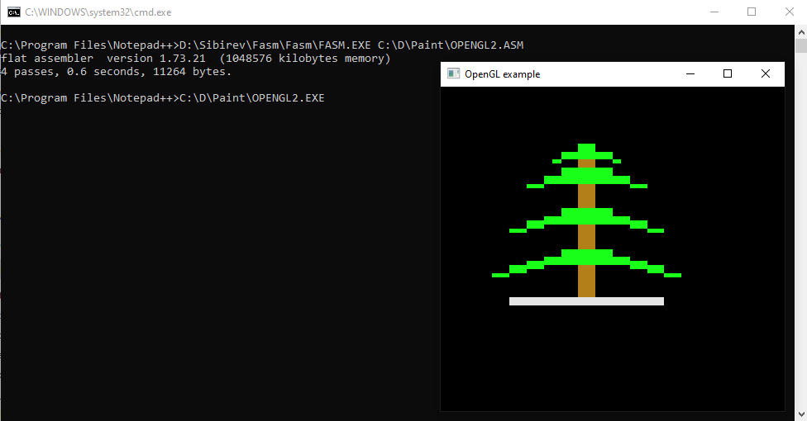

**Полный код программы:**

; OpenGL programming example

format PE64 GUI 5.0

entry start

;????? ????? ???? ????

include 'D:\Sibirev\Fasm\Fasm\INCLUDE\WIN64A.INC'

;????? ????? ???? ????

include 'C:\D\Paint\OPENGL.INC'

section '.text' code readable executable

rectangle:

ret

start:

;//???????? ???? ? ??? ???????????

sub rsp,8 ; Make stack dqword aligned

invoke GetModuleHandle,0

mov [wc.hInstance],rax

invoke LoadIcon,0,IDI_APPLICATION

mov [wc.hIcon],rax

invoke LoadCursor,0,IDC_ARROW

mov [wc.hCursor],rax

invoke RegisterClass,wc

invoke CreateWindowEx,0,_class,_title,WS_VISIBLE+WS_OVERLAPPEDWINDOW+WS_CLIPCHILDREN+WS_CLIPSIBLINGS,16,16,432,432,NULL,NULL,[wc.hInstance],NULL

;?????????? ???????? ????

msg_loop:

invoke GetMessage,addr msg,NULL,0,0

cmp eax,1

jb end_loop;???? eax ==0 ?? ????? ?? ?????????

jne msg_loop;???? eax !=1 ?? ??? ??????? ????

invoke TranslateMessage,addr msg

invoke DispatchMessage,addr msg

jmp msg_loop

end_loop:

invoke ExitProcess,[msg.wParam]

;?????????, ??????? ??????????? ??????????? ???- ?? ???

proc WindowProc uses rbx rsi rdi, hwnd,wmsg,wparam,lparam

mov [hwnd],rcx

frame

cmp edx,WM_CREATE

je .wmcreate

cmp edx,WM_SIZE

je .wmsize

cmp edx,WM_PAINT

je .wmpaint

cmp edx,WM_KEYDOWN

je .wmkeydown

cmp edx,WM_DESTROY

je .wmdestroy

.defwndproc:

invoke DefWindowProc,rcx,rdx,r8,r9

jmp .finish

.wmcreate:

invoke GetDC,rcx

mov [hdc],rax

lea rdi,[pfd]

mov rcx,sizeof.PIXELFORMATDESCRIPTOR shr 3

xor eax,eax

rep stosq

mov [pfd.nSize],sizeof.PIXELFORMATDESCRIPTOR

mov [pfd.nVersion],1

mov [pfd.dwFlags],PFD_SUPPORT_OPENGL+PFD_DOUBLEBUFFER+PFD_DRAW_TO_WINDOW

mov [pfd.iLayerType],PFD_MAIN_PLANE

mov [pfd.iPixelType],PFD_TYPE_RGBA

mov [pfd.cColorBits],16

mov [pfd.cDepthBits],16

mov [pfd.cAccumBits],0

mov [pfd.cStencilBits],0

invoke ChoosePixelFormat,[hdc],addr pfd

invoke SetPixelFormat,[hdc],eax,addr pfd

invoke wglCreateContext,[hdc]

mov [hrc],rax

invoke wglMakeCurrent,[hdc],[hrc]

invoke GetClientRect,[hwnd],addr rc

invoke glViewport,0,0,[rc.right],[rc.bottom]

invoke GetTickCount

mov [clock],eax

xor eax,eax

jmp .finish

.wmsize:

invoke GetClientRect,[hwnd],addr rc

invoke glViewport,0,0,[rc.right],[rc.bottom]

xor eax,eax

jmp .finish

.wmpaint:;?????? ?????

invoke GetTickCount

sub eax,[clock]

cmp eax,10

jb .animation_ok

add [clock],eax

;;???????? ?????? ??? ????

;invoke glRotatef,float [theta],float dword 0.0,float dword 0.0,float dword 1.0

.animation_ok:

invoke glClear,GL_COLOR_BUFFER_BIT

;???? ??? ????????? ????? ??????

;?????? ??????

invoke glBegin,GL_QUADS

invoke glColor3f,float dword 0.9,float dword 0.9,float dword 0.9

;(-0.5;0.5);(-0.2;0.5)

;(-0.5;0.2);(-0.2;0.2)

invoke glVertex3d,float -0.6,float -0.35,float 0.0

invoke glVertex3d,float 0.3,float -0.35,float 0.0

invoke glVertex3d,float 0.3,float -0.30,float 0.0

invoke glVertex3d,float -0.6,float -0.30,float 0.0

invoke glVertex3d,float -0.6,float -0.35,float 0.0

;(-0.4;0.2);(-0.3;0.1)

;(-0.4;0.2);(-0.3;0.1)

invoke glEnd

;?????? ???

invoke glBegin,GL_QUADS

invoke glColor3f,float dword 0.7,float dword 0.5,float dword 0.1

;(-0.4;0.2);(-0.3;0.1)

;(-0.4;0.2);(-0.3;0.1)

invoke glVertex3d,float -0.2,float 0.65,float 0.0

invoke glVertex3d,float -0.1,float 0.65,float 0.0

invoke glVertex3d,float -0.1,float -0.3,float 0.0

invoke glVertex3d,float -0.2,float -0.3,float 0.0

invoke glVertex3d,float -0.2,float 0.65,float 0.0

invoke glEnd

invoke glBegin,GL_QUADS

invoke glColor3f,float dword 0.1,float dword 1.0,float dword 0.1

;(-0.4;0.2);(-0.3;0.1)

;(-0.4;0.2);(-0.3;0.1)

invoke glVertex3d,float -0.3,float 0.5,float 0.0

invoke glVertex3d,float 0.0,float 0.5,float 0.0

invoke glVertex3d,float 0.0,float 0.4,float 0.0

invoke glVertex3d,float -0.3,float 0.4,float 0.0

invoke glVertex3d,float -0.3,float 0.5,float 0.0

invoke glEnd

invoke glBegin,GL_QUADS

invoke glColor3f,float dword 0.1,float dword 1.0,float dword 0.1

;(-0.4;0.2);(-0.3;0.1)

;(-0.4;0.2);(-0.3;0.1)

invoke glVertex3d,float -0.3,float 0.25,float 0.0

invoke glVertex3d,float 0.0,float 0.25,float 0.0

invoke glVertex3d,float 0.0,float 0.15,float 0.0

invoke glVertex3d,float -0.3,float 0.15,float 0.0

invoke glVertex3d,float -0.3,float 0.25,float 0.0

invoke glEnd

invoke glBegin,GL_QUADS

invoke glColor3f,float dword 0.1,float dword 1.0,float dword 0.1

;(-0.4;0.2);(-0.3;0.1)

;(-0.4;0.2);(-0.3;0.1)

invoke glVertex3d,float -0.3,float 0.0,float 0.0

invoke glVertex3d,float 0.0,float 0.0,float 0.0

invoke glVertex3d,float 0.0,float -0.1,float 0.0

invoke glVertex3d,float -0.3,float -0.1,float 0.0

invoke glVertex3d,float -0.3,float 0.0,float 0.0

invoke glEnd

invoke glBegin,GL_QUADS

invoke glColor3f,float dword 0.1,float dword 1.0,float dword 0.1

;(-0.4;0.2);(-0.3;0.1)

;(-0.4;0.2);(-0.3;0.1)

invoke glVertex3d,float -0.3,float 0.6,float 0.0

invoke glVertex3d,float 0.0,float 0.6,float 0.0

invoke glVertex3d,float 0.0,float 0.55,float 0.0

invoke glVertex3d,float -0.3,float 0.55,float 0.0

invoke glVertex3d,float -0.3,float 0.6,float 0.0

invoke glEnd

invoke glBegin,GL_QUADS

invoke glColor3f,float dword 0.1,float dword 1.0,float dword 0.1

;(-0.4;0.2);(-0.3;0.1)

;(-0.4;0.2);(-0.3;0.1)

invoke glVertex3d,float -0.35,float 0.55,float 0.0

invoke glVertex3d,float -0.3,float 0.55,float 0.0

invoke glVertex3d,float -0.3,float 0.525,float 0.0

invoke glVertex3d,float -0.35,float 0.525,float 0.0

invoke glVertex3d,float -0.35,float 0.55,float 0.0

invoke glEnd

invoke glBegin,GL_QUADS

invoke glColor3f,float dword 0.1,float dword 1.0,float dword 0.1

;(-0.4;0.2);(-0.3;0.1)

;(-0.4;0.2);(-0.3;0.1)

invoke glVertex3d,float 0.0,float 0.55,float 0.0

invoke glVertex3d,float 0.05,float 0.55,float 0.0

invoke glVertex3d,float 0.05,float 0.525,float 0.0

invoke glVertex3d,float 0.0,float 0.525,float 0.0

invoke glVertex3d,float 0.0,float 0.55,float 0.0

invoke glEnd

invoke glBegin,GL_QUADS

invoke glColor3f,float dword 0.1,float dword 1.0,float dword 0.1

;(-0.4;0.2);(-0.3;0.1)

;(-0.4;0.2);(-0.3;0.1)

invoke glVertex3d,float 0.0,float 0.45,float 0.0

invoke glVertex3d,float 0.1,float 0.45,float 0.0

invoke glVertex3d,float 0.1,float 0.4,float 0.0

invoke glVertex3d,float 0.0,float 0.4,float 0.0

invoke glVertex3d,float 0.0,float 0.45,float 0.0

invoke glEnd

invoke glBegin,GL_QUADS

invoke glColor3f,float dword 0.1,float dword 1.0,float dword 0.1

;(-0.4;0.2);(-0.3;0.1)

;(-0.4;0.2);(-0.3;0.1)

invoke glVertex3d,float -0.4,float 0.45,float 0.0

invoke glVertex3d,float -0.3,float 0.45,float 0.0

invoke glVertex3d,float -0.3,float 0.4,float 0.0

invoke glVertex3d,float -0.4,float 0.4,float 0.0

invoke glVertex3d,float -0.4,float 0.45,float 0.0

invoke glEnd

invoke glBegin,GL_QUADS

invoke glColor3f,float dword 0.1,float dword 1.0,float dword 0.1

;(-0.4;0.2);(-0.3;0.1)

;(-0.4;0.2);(-0.3;0.1)

invoke glVertex3d,float -0.4,float 0.2,float 0.0

invoke glVertex3d,float -0.3,float 0.2,float 0.0

invoke glVertex3d,float -0.3,float 0.15,float 0.0

invoke glVertex3d,float -0.4,float 0.15,float 0.0

invoke glVertex3d,float -0.4,float 0.2,float 0.0

invoke glEnd

invoke glBegin,GL_QUADS

invoke glColor3f,float dword 0.1,float dword 1.0,float dword 0.1

;(-0.4;0.2);(-0.3;0.1)

;(-0.4;0.2);(-0.3;0.1)

invoke glVertex3d,float 0.0,float 0.2,float 0.0

invoke glVertex3d,float 0.1,float 0.2,float 0.0

invoke glVertex3d,float 0.1,float 0.15,float 0.0

invoke glVertex3d,float 0.0,float 0.15,float 0.0

invoke glVertex3d,float 0.0,float 0.2,float 0.0

invoke glEnd

invoke glBegin,GL_QUADS

invoke glColor3f,float dword 0.1,float dword 1.0,float dword 0.1

;(-0.4;0.2);(-0.3;0.1)

;(-0.4;0.2);(-0.3;0.1)

invoke glVertex3d,float -0.4,float -0.05,float 0.0

invoke glVertex3d,float -0.3,float -0.05,float 0.0

invoke glVertex3d,float -0.3,float -0.1,float 0.0

invoke glVertex3d,float -0.4,float -0.1,float 0.0

invoke glVertex3d,float -0.4,float -0.05,float 0.0

invoke glEnd

invoke glBegin,GL_QUADS

invoke glColor3f,float dword 0.1,float dword 1.0,float dword 0.1

;(-0.4;0.2);(-0.3;0.1)

;(-0.4;0.2);(-0.3;0.1)

invoke glVertex3d,float 0.0,float -0.05,float 0.0

invoke glVertex3d,float 0.1,float -0.05,float 0.0

invoke glVertex3d,float 0.1,float -0.1,float 0.0

invoke glVertex3d,float 0.0,float -0.1,float 0.0

invoke glVertex3d,float 0.0,float -0.05,float 0.0

invoke glEnd

invoke glBegin,GL_QUADS

invoke glColor3f,float dword 0.1,float dword 1.0,float dword 0.1

;(-0.4;0.2);(-0.3;0.1)

;(-0.4;0.2);(-0.3;0.1)

invoke glVertex3d,float 0.1,float -0.075,float 0.0

invoke glVertex3d,float 0.2,float -0.075,float 0.0

invoke glVertex3d,float 0.2,float -0.125,float 0.0

invoke glVertex3d,float 0.1,float -0.125,float 0.0

invoke glVertex3d,float 0.1,float -0.075,float 0.0

invoke glEnd

invoke glBegin,GL_QUADS

invoke glColor3f,float dword 0.1,float dword 1.0,float dword 0.1

;(-0.4;0.2);(-0.3;0.1)

;(-0.4;0.2);(-0.3;0.1)

invoke glVertex3d,float -0.5,float -0.075,float 0.0

invoke glVertex3d,float -0.4,float -0.075,float 0.0

invoke glVertex3d,float -0.4,float -0.125,float 0.0

invoke glVertex3d,float -0.5,float -0.125,float 0.0

invoke glVertex3d,float -0.5,float -0.075,float 0.0

invoke glEnd

invoke glBegin,GL_QUADS

invoke glColor3f,float dword 0.1,float dword 1.0,float dword 0.1

;(-0.4;0.2);(-0.3;0.1)

;(-0.4;0.2);(-0.3;0.1)

invoke glVertex3d,float 0.1,float 0.375,float 0.0

invoke glVertex3d,float 0.2,float 0.375,float 0.0

invoke glVertex3d,float 0.2,float 0.4,float 0.0

invoke glVertex3d,float 0.1,float 0.4,float 0.0

invoke glVertex3d,float 0.1,float 0.375,float 0.0

invoke glEnd

invoke glBegin,GL_QUADS

invoke glColor3f,float dword 0.1,float dword 1.0,float dword 0.1

;(-0.4;0.2);(-0.3;0.1)

;(-0.4;0.2);(-0.3;0.1)

invoke glVertex3d,float -0.4,float 0.375,float 0.0

invoke glVertex3d,float -0.5,float 0.375,float 0.0

invoke glVertex3d,float -0.5,float 0.4,float 0.0

invoke glVertex3d,float -0.4,float 0.4,float 0.0

invoke glVertex3d,float -0.4,float 0.375,float 0.0

invoke glEnd

invoke glBegin,GL_QUADS

invoke glColor3f,float dword 0.1,float dword 1.0,float dword 0.1

;(-0.4;0.2);(-0.3;0.1)

;(-0.4;0.2);(-0.3;0.1)

invoke glVertex3d,float -0.5,float 0.175,float 0.0

invoke glVertex3d,float -0.4,float 0.175,float 0.0

invoke glVertex3d,float -0.4,float 0.125,float 0.0

invoke glVertex3d,float -0.5,float 0.125,float 0.0

invoke glVertex3d,float -0.5,float 0.175,float 0.0

invoke glEnd

invoke glBegin,GL_QUADS

invoke glColor3f,float dword 0.1,float dword 1.0,float dword 0.1

;(-0.4;0.2);(-0.3;0.1)

;(-0.4;0.2);(-0.3;0.1)

invoke glVertex3d,float 0.1,float 0.175,float 0.0

invoke glVertex3d,float 0.2,float 0.175,float 0.0

invoke glVertex3d,float 0.2,float 0.125,float 0.0

invoke glVertex3d,float 0.1,float 0.125,float 0.0

invoke glVertex3d,float 0.1,float 0.175,float 0.0

invoke glEnd

invoke glBegin,GL_QUADS

invoke glColor3f,float dword 0.1,float dword 1.0,float dword 0.1

;(-0.4;0.2);(-0.3;0.1)

;(-0.4;0.2);(-0.3;0.1)

invoke glVertex3d,float -0.6,float 0.125,float 0.0

invoke glVertex3d,float -0.5,float 0.125,float 0.0

invoke glVertex3d,float -0.5,float 0.1,float 0.0

invoke glVertex3d,float -0.6,float 0.1,float 0.0

invoke glVertex3d,float -0.6,float 0.125,float 0.0

invoke glEnd

invoke glBegin,GL_QUADS

invoke glColor3f,float dword 0.1,float dword 1.0,float dword 0.1

;(-0.4;0.2);(-0.3;0.1)

;(-0.4;0.2);(-0.3;0.1)

invoke glVertex3d,float 0.3,float 0.125,float 0.0

invoke glVertex3d,float 0.2,float 0.125,float 0.0

invoke glVertex3d,float 0.2,float 0.1,float 0.0

invoke glVertex3d,float 0.3,float 0.1,float 0.0

invoke glVertex3d,float 0.3,float 0.125,float 0.0

invoke glEnd

invoke glBegin,GL_QUADS

invoke glColor3f,float dword 0.1,float dword 1.0,float dword 0.1

;(-0.4;0.2);(-0.3;0.1)

;(-0.4;0.2);(-0.3;0.1)

invoke glVertex3d,float -0.6,float -0.1,float 0.0

invoke glVertex3d,float -0.5,float -0.1,float 0.0

invoke glVertex3d,float -0.5,float -0.15,float 0.0

invoke glVertex3d,float -0.6,float -0.15,float 0.0

invoke glVertex3d,float -0.6,float -0.1,float 0.0

invoke glEnd

invoke glBegin,GL_QUADS

invoke glColor3f,float dword 0.1,float dword 1.0,float dword 0.1

;(-0.4;0.2);(-0.3;0.1)

;(-0.4;0.2);(-0.3;0.1)

invoke glVertex3d,float 0.3,float -0.1,float 0.0

invoke glVertex3d,float 0.2,float -0.1,float 0.0

invoke glVertex3d,float 0.2,float -0.15,float 0.0

invoke glVertex3d,float 0.3,float -0.15,float 0.0

invoke glVertex3d,float 0.3,float -0.1,float 0.0

invoke glEnd

invoke glBegin,GL_QUADS

invoke glColor3f,float dword 0.1,float dword 1.0,float dword 0.1

;(-0.4;0.2);(-0.3;0.1)

;(-0.4;0.2);(-0.3;0.1)

invoke glVertex3d,float -0.7,float -0.15,float 0.0

invoke glVertex3d,float -0.6,float -0.15,float 0.0

invoke glVertex3d,float -0.6,float -0.175,float 0.0

invoke glVertex3d,float -0.7,float -0.175,float 0.0

invoke glVertex3d,float -0.7,float -0.15,float 0.0

invoke glEnd

invoke glBegin,GL_QUADS

invoke glColor3f,float dword 0.1,float dword 1.0,float dword 0.1

;(-0.4;0.2);(-0.3;0.1)

;(-0.4;0.2);(-0.3;0.1)

invoke glVertex3d,float 0.4,float -0.15,float 0.0

invoke glVertex3d,float 0.3,float -0.15,float 0.0

invoke glVertex3d,float 0.3,float -0.175,float 0.0

invoke glVertex3d,float 0.4,float -0.175,float 0.0

invoke glVertex3d,float 0.4,float -0.15,float 0.0

invoke glEnd

invoke glBegin,GL_QUADS

invoke glColor3f,float dword 0.1,float dword 1.0,float dword 0.1

;(-0.4;0.2);(-0.3;0.1)

;(-0.4;0.2);(-0.3;0.1)

invoke glVertex3d,float -0.2,float 0.65,float 0.0

invoke glVertex3d,float -0.1,float 0.65,float 0.0

invoke glVertex3d,float -0.1,float 0.6,float 0.0

invoke glVertex3d,float -0.2,float 0.6,float 0.0

invoke glVertex3d,float -0.2,float 0.65,float 0.0

invoke glEnd

invoke SwapBuffers,[hdc]

xor eax,eax

jmp .finish

.wmkeydown:

cmp r8d,VK_ESCAPE

jne .defwndproc

.wmdestroy:

invoke wglMakeCurrent,0,0

invoke wglDeleteContext,[hrc]

invoke ReleaseDC,[hwnd],[hdc]

invoke PostQuitMessage,0

xor eax,eax

.finish:

endf

ret

endp

section '.data' data readable writeable

_title db 'OpenGL example',0

_class db 'FASMOPENGL32',0

theta GLfloat 0.6

wc WNDCLASS 0,WindowProc,0,0,NULL,NULL,NULL,NULL,NULL,_class

hdc dq ?

hrc dq ?

msg MSG

rc RECT

pfd PIXELFORMATDESCRIPTOR

clock dd ?

section '.idata' import data readable writeable

library kernel,'KERNEL32.DLL',\

user,'USER32.DLL',\

gdi,'GDI32.DLL',\

opengl,'OPENGL32.DLL',\

glu,'GLU32.DLL'

import kernel,\

GetModuleHandle,'GetModuleHandleA',\

GetTickCount,'GetTickCount',\

ExitProcess,'ExitProcess'

import user,\

RegisterClass,'RegisterClassA',\

CreateWindowEx,'CreateWindowExA',\

DefWindowProc,'DefWindowProcA',\

GetMessage,'GetMessageA',\

TranslateMessage,'TranslateMessage',\

DispatchMessage,'DispatchMessageA',\

LoadCursor,'LoadCursorA',\

LoadIcon,'LoadIconA',\

GetClientRect,'GetClientRect',\

GetDC,'GetDC',\

ReleaseDC,'ReleaseDC',\

PostQuitMessage,'PostQuitMessage'

import gdi,\

ChoosePixelFormat,'ChoosePixelFormat',\

SetPixelFormat,'SetPixelFormat',\

SwapBuffers,'SwapBuffers'

import opengl,\

glAccum,'glAccum',\

glAlphaFunc,'glAlphaFunc',\

glAreTexturesResident,'glAreTexturesResident',\

glArrayElement,'glArrayElement',\

glBegin,'glBegin',\

glBindTexture,'glBindTexture',\

glBitmap,'glBitmap',\

glBlendFunc,'glBlendFunc',\

glCallList,'glCallList',\

glCallLists,'glCallLists',\

glClear,'glClear',\

glClearAccum,'glClearAccum',\

glClearColor,'glClearColor',\

glClearDepth,'glClearDepth',\

glClearIndex,'glClearIndex',\

glClearStencil,'glClearStencil',\

glClipPlane,'glClipPlane',\

glColor3b,'glColor3b',\

glColor3bv,'glColor3bv',\

glColor3d,'glColor3d',\

glColor3dv,'glColor3dv',\

glColor3f,'glColor3f',\

glColor3fv,'glColor3fv',\

glColor3i,'glColor3i',\

glColor3iv,'glColor3iv',\

glColor3s,'glColor3s',\

glColor3sv,'glColor3sv',\

glColor3ub,'glColor3ub',\

glColor3ubv,'glColor3ubv',\

glColor3ui,'glColor3ui',\

glColor3uiv,'glColor3uiv',\

glColor3us,'glColor3us',\

glColor3usv,'glColor3usv',\

glColor4b,'glColor4b',\

glColor4bv,'glColor4bv',\

glColor4d,'glColor4d',\

glColor4dv,'glColor4dv',\

glColor4f,'glColor4f',\

glColor4fv,'glColor4fv',\

glColor4i,'glColor4i',\

glColor4iv,'glColor4iv',\

glColor4s,'glColor4s',\

glColor4sv,'glColor4sv',\

glColor4ub,'glColor4ub',\

glColor4ubv,'glColor4ubv',\

glColor4ui,'glColor4ui',\

glColor4uiv,'glColor4uiv',\

glColor4us,'glColor4us',\

glColor4usv,'glColor4usv',\

glColorMask,'glColorMask',\

glColorMaterial,'glColorMaterial',\

glColorPointer,'glColorPointer',\

glCopyPixels,'glCopyPixels',\

glCopyTexImage1D,'glCopyTexImage1D',\

glCopyTexImage2D,'glCopyTexImage2D',\

glCopyTexSubImage1D,'glCopyTexSubImage1D',\

glCopyTexSubImage2D,'glCopyTexSubImage2D',\

glCullFace,'glCullFace',\

glDeleteLists,'glDeleteLists',\

glDeleteTextures,'glDeleteTextures',\

glDepthFunc,'glDepthFunc',\

glDepthMask,'glDepthMask',\

glDepthRange,'glDepthRange',\

glDisable,'glDisable',\

glDisableClientState,'glDisableClientState',\

glDrawArrays,'glDrawArrays',\

glDrawBuffer,'glDrawBuffer',\

glDrawElements,'glDrawElements',\

glDrawPixels,'glDrawPixels',\

glEdgeFlag,'glEdgeFlag',\

glEdgeFlagPointer,'glEdgeFlagPointer',\

glEdgeFlagv,'glEdgeFlagv',\

glEnable,'glEnable',\

glEnableClientState,'glEnableClientState',\

glEnd,'glEnd',\

glEndList,'glEndList',\

glEvalCoord1d,'glEvalCoord1d',\

glEvalCoord1dv,'glEvalCoord1dv',\

glEvalCoord1f,'glEvalCoord1f',\

glEvalCoord1fv,'glEvalCoord1fv',\

glEvalCoord2d,'glEvalCoord2d',\

glEvalCoord2dv,'glEvalCoord2dv',\

glEvalCoord2f,'glEvalCoord2f',\

glEvalCoord2fv,'glEvalCoord2fv',\

glEvalMesh1,'glEvalMesh1',\

glEvalMesh2,'glEvalMesh2',\

glEvalPoint1,'glEvalPoint1',\

glEvalPoint2,'glEvalPoint2',\

glFeedbackBuffer,'glFeedbackBuffer',\

glFinish,'glFinish',\

glFlush,'glFlush',\

glFogf,'glFogf',\

glFogfv,'glFogfv',\

glFogi,'glFogi',\

glFogiv,'glFogiv',\

glFrontFace,'glFrontFace',\

glFrustum,'glFrustum',\

glGenLists,'glGenLists',\

glGenTextures,'glGenTextures',\

glGetBooleanv,'glGetBooleanv',\

glGetClipPlane,'glGetClipPlane',\

glGetDoublev,'glGetDoublev',\

glGetError,'glGetError',\

glGetFloatv,'glGetFloatv',\

glGetIntegerv,'glGetIntegerv',\

glGetLightfv,'glGetLightfv',\

glGetLightiv,'glGetLightiv',\

glGetMapdv,'glGetMapdv',\

glGetMapfv,'glGetMapfv',\

glGetMapiv,'glGetMapiv',\

glGetMaterialfv,'glGetMaterialfv',\

glGetMaterialiv,'glGetMaterialiv',\

glGetPixelMapfv,'glGetPixelMapfv',\

glGetPixelMapuiv,'glGetPixelMapuiv',\

glGetPixelMapusv,'glGetPixelMapusv',\

glGetPointerv,'glGetPointerv',\

glGetPolygonStipple,'glGetPolygonStipple',\

glGetString,'glGetString',\

glGetTexEnvfv,'glGetTexEnvfv',\

glGetTexEnviv,'glGetTexEnviv',\

glGetTexGendv,'glGetTexGendv',\

glGetTexGenfv,'glGetTexGenfv',\

glGetTexGeniv,'glGetTexGeniv',\

glGetTexImage,'glGetTexImage',\

glGetTexLevelParameterfv,'glGetTexLevelParameterfv',\

glGetTexLevelParameteriv,'glGetTexLevelParameteriv',\

glGetTexParameterfv,'glGetTexParameterfv',\

glGetTexParameteriv,'glGetTexParameteriv',\

glHint,'glHint',\

glIndexMask,'glIndexMask',\

glIndexPointer,'glIndexPointer',\

glIndexd,'glIndexd',\

glIndexdv,'glIndexdv',\

glIndexf,'glIndexf',\

glIndexfv,'glIndexfv',\

glIndexi,'glIndexi',\

glIndexiv,'glIndexiv',\

glIndexs,'glIndexs',\

glIndexsv,'glIndexsv',\

glIndexub,'glIndexub',\

glIndexubv,'glIndexubv',\

glInitNames,'glInitNames',\

glInterleavedArrays,'glInterleavedArrays',\

glIsEnabled,'glIsEnabled',\

glIsList,'glIsList',\

glIsTexture,'glIsTexture',\

glLightModelf,'glLightModelf',\

glLightModelfv,'glLightModelfv',\

glLightModeli,'glLightModeli',\

glLightModeliv,'glLightModeliv',\

glLightf,'glLightf',\

glLightfv,'glLightfv',\

glLighti,'glLighti',\

glLightiv,'glLightiv',\

glLineStipple,'glLineStipple',\

glLineWidth,'glLineWidth',\

glListBase,'glListBase',\

glLoadIdentity,'glLoadIdentity',\

glLoadMatrixd,'glLoadMatrixd',\

glLoadMatrixf,'glLoadMatrixf',\

glLoadName,'glLoadName',\

glLogicOp,'glLogicOp',\

glMap1d,'glMap1d',\

glMap1f,'glMap1f',\

glMap2d,'glMap2d',\

glMap2f,'glMap2f',\

glMapGrid1d,'glMapGrid1d',\

glMapGrid1f,'glMapGrid1f',\

glMapGrid2d,'glMapGrid2d',\

glMapGrid2f,'glMapGrid2f',\

glMaterialf,'glMaterialf',\

glMaterialfv,'glMaterialfv',\

glMateriali,'glMateriali',\

glMaterialiv,'glMaterialiv',\

glMatrixMode,'glMatrixMode',\

glMultMatrixd,'glMultMatrixd',\

glMultMatrixf,'glMultMatrixf',\

glNewList,'glNewList',\

glNormal3b,'glNormal3b',\

glNormal3bv,'glNormal3bv',\

glNormal3d,'glNormal3d',\

glNormal3dv,'glNormal3dv',\

glNormal3f,'glNormal3f',\

glNormal3fv,'glNormal3fv',\

glNormal3i,'glNormal3i',\

glNormal3iv,'glNormal3iv',\

glNormal3s,'glNormal3s',\

glNormal3sv,'glNormal3sv',\

glNormalPointer,'glNormalPointer',\

glOrtho,'glOrtho',\

glPassThrough,'glPassThrough',\

glPixelMapfv,'glPixelMapfv',\

glPixelMapuiv,'glPixelMapuiv',\

glPixelMapusv,'glPixelMapusv',\

glPixelStoref,'glPixelStoref',\

glPixelStorei,'glPixelStorei',\

glPixelTransferf,'glPixelTransferf',\

glPixelTransferi,'glPixelTransferi',\

glPixelZoom,'glPixelZoom',\

glPointSize,'glPointSize',\

glPolygonMode,'glPolygonMode',\

glPolygonOffset,'glPolygonOffset',\

glPolygonStipple,'glPolygonStipple',\

glPopAttrib,'glPopAttrib',\

glPopClientAttrib,'glPopClientAttrib',\

glPopMatrix,'glPopMatrix',\

glPopName,'glPopName',\

glPrioritizeTextures,'glPrioritizeTextures',\

glPushAttrib,'glPushAttrib',\

glPushClientAttrib,'glPushClientAttrib',\

glPushMatrix,'glPushMatrix',\

glPushName,'glPushName',\

glRasterPos2d,'glRasterPos2d',\

glRasterPos2dv,'glRasterPos2dv',\

glRasterPos2f,'glRasterPos2f',\

glRasterPos2fv,'glRasterPos2fv',\

glRasterPos2i,'glRasterPos2i',\

glRasterPos2iv,'glRasterPos2iv',\

glRasterPos2s,'glRasterPos2s',\

glRasterPos2sv,'glRasterPos2sv',\

glRasterPos3d,'glRasterPos3d',\

glRasterPos3dv,'glRasterPos3dv',\

glRasterPos3f,'glRasterPos3f',\

glRasterPos3fv,'glRasterPos3fv',\

glRasterPos3i,'glRasterPos3i',\

glRasterPos3iv,'glRasterPos3iv',\

glRasterPos3s,'glRasterPos3s',\

glRasterPos3sv,'glRasterPos3sv',\

glRasterPos4d,'glRasterPos4d',\

glRasterPos4dv,'glRasterPos4dv',\

glRasterPos4f,'glRasterPos4f',\

glRasterPos4fv,'glRasterPos4fv',\

glRasterPos4i,'glRasterPos4i',\

glRasterPos4iv,'glRasterPos4iv',\

glRasterPos4s,'glRasterPos4s',\

glRasterPos4sv,'glRasterPos4sv',\

glReadBuffer,'glReadBuffer',\

glReadPixels,'glReadPixels',\

glRectd,'glRectd',\

glRectdv,'glRectdv',\

glRectf,'glRectf',\

glRectfv,'glRectfv',\

glRecti,'glRecti',\

glRectiv,'glRectiv',\

glRects,'glRects',\

glRectsv,'glRectsv',\

glRenderMode,'glRenderMode',\

glRotated,'glRotated',\

glRotatef,'glRotatef',\

glScaled,'glScaled',\

glScalef,'glScalef',\

glScissor,'glScissor',\

glSelectBuffer,'glSelectBuffer',\

glShadeModel,'glShadeModel',\

glStencilFunc,'glStencilFunc',\

glStencilMask,'glStencilMask',\

glStencilOp,'glStencilOp',\

glTexCoord1d,'glTexCoord1d',\

glTexCoord1dv,'glTexCoord1dv',\

glTexCoord1f,'glTexCoord1f',\

glTexCoord1fv,'glTexCoord1fv',\

glTexCoord1i,'glTexCoord1i',\

glTexCoord1iv,'glTexCoord1iv',\

glTexCoord1s,'glTexCoord1s',\

glTexCoord1sv,'glTexCoord1sv',\

glTexCoord2d,'glTexCoord2d',\

glTexCoord2dv,'glTexCoord2dv',\

glTexCoord2f,'glTexCoord2f',\

glTexCoord2fv,'glTexCoord2fv',\

glTexCoord2i,'glTexCoord2i',\

glTexCoord2iv,'glTexCoord2iv',\

glTexCoord2s,'glTexCoord2s',\

glTexCoord2sv,'glTexCoord2sv',\

glTexCoord3d,'glTexCoord3d',\

glTexCoord3dv,'glTexCoord3dv',\

glTexCoord3f,'glTexCoord3f',\

glTexCoord3fv,'glTexCoord3fv',\

glTexCoord3i,'glTexCoord3i',\

glTexCoord3iv,'glTexCoord3iv',\

glTexCoord3s,'glTexCoord3s',\

glTexCoord3sv,'glTexCoord3sv',\

glTexCoord4d,'glTexCoord4d',\

glTexCoord4dv,'glTexCoord4dv',\

glTexCoord4f,'glTexCoord4f',\

glTexCoord4fv,'glTexCoord4fv',\

glTexCoord4i,'glTexCoord4i',\

glTexCoord4iv,'glTexCoord4iv',\

glTexCoord4s,'glTexCoord4s',\

glTexCoord4sv,'glTexCoord4sv',\

glTexCoordPointer,'glTexCoordPointer',\

glTexEnvf,'glTexEnvf',\

glTexEnvfv,'glTexEnvfv',\

glTexEnvi,'glTexEnvi',\

glTexEnviv,'glTexEnviv',\

glTexGend,'glTexGend',\

glTexGendv,'glTexGendv',\

glTexGenf,'glTexGenf',\

glTexGenfv,'glTexGenfv',\

glTexGeni,'glTexGeni',\

glTexGeniv,'glTexGeniv',\

glTexImage1D,'glTexImage1D',\

glTexImage2D,'glTexImage2D',\

glTexParameterf,'glTexParameterf',\

glTexParameterfv,'glTexParameterfv',\

glTexParameteri,'glTexParameteri',\

glTexParameteriv,'glTexParameteriv',\

glTexSubImage1D,'glTexSubImage1D',\

glTexSubImage2D,'glTexSubImage2D',\

glTranslated,'glTranslated',\

glTranslatef,'glTranslatef',\

glVertex2d,'glVertex2d',\

glVertex2dv,'glVertex2dv',\

glVertex2f,'glVertex2f',\

glVertex2fv,'glVertex2fv',\

glVertex2i,'glVertex2i',\

glVertex2iv,'glVertex2iv',\

glVertex2s,'glVertex2s',\

glVertex2sv,'glVertex2sv',\

glVertex3d,'glVertex3d',\

glVertex3dv,'glVertex3dv',\

glVertex3f,'glVertex3f',\

glVertex3fv,'glVertex3fv',\

glVertex3i,'glVertex3i',\

glVertex3iv,'glVertex3iv',\

glVertex3s,'glVertex3s',\

glVertex3sv,'glVertex3sv',\

glVertex4d,'glVertex4d',\

glVertex4dv,'glVertex4dv',\

glVertex4f,'glVertex4f',\

glVertex4fv,'glVertex4fv',\

glVertex4i,'glVertex4i',\

glVertex4iv,'glVertex4iv',\

glVertex4s,'glVertex4s',\

glVertex4sv,'glVertex4sv',\

glVertexPointer,'glVertexPointer',\

glViewport,'glViewport',\

wglGetProcAddress,'wglGetProcAddress',\

wglCopyContext,'wglCopyContext',\

wglCreateContext,'wglCreateContext',\

wglCreateLayerContext,'wglCreateLayerContext',\

wglDeleteContext,'wglDeleteContext',\

wglDescribeLayerPlane,'wglDescribeLayerPlane',\

wglGetCurrentContext,'wglGetCurrentContext',\

wglGetCurrentDC,'wglGetCurrentDC',\

wglGetLayerPaletteEntries,'wglGetLayerPaletteEntries',\

wglMakeCurrent,'wglMakeCurrent',\

wglRealizeLayerPalette,'wglRealizeLayerPalette',\

wglSetLayerPaletteEntries,'wglSetLayerPaletteEntries',\

wglShareLists,'wglShareLists',\

wglSwapLayerBuffers,'wglSwapLayerBuffers',\

wglSwapMultipleBuffers,'wglSwapMultipleBuffers',\

wglUseFontBitmapsA,'wglUseFontBitmapsA',\

wglUseFontOutlinesA,'wglUseFontOutlinesA',\

wglUseFontBitmapsW,'wglUseFontBitmapsW',\

wglUseFontOutlinesW,'wglUseFontOutlinesW',\

glDrawRangeElements,'glDrawRangeElements',\

glTexImage3D,'glTexImage3D',\

glBlendColor,'glBlendColor',\

glBlendEquation,'glBlendEquation',\

glColorSubTable,'glColorSubTable',\

glCopyColorSubTable,'glCopyColorSubTable',\

glColorTable,'glColorTable',\

glCopyColorTable,'glCopyColorTable',\

glColorTableParameteriv,'glColorTableParameteriv',\

glColorTableParameterfv,'glColorTableParameterfv',\

glGetColorTable,'glGetColorTable',\

glGetColorTableParameteriv,'glGetColorTableParameteriv',\

glGetColorTableParameterfv,'glGetColorTableParameterfv',\

glConvolutionFilter1D,'glConvolutionFilter1D',\

glConvolutionFilter2D,'glConvolutionFilter2D',\

glCopyConvolutionFilter1D,'glCopyConvolutionFilter1D',\

glCopyConvolutionFilter2D,'glCopyConvolutionFilter2D',\

glGetConvolutionFilter,'glGetConvolutionFilter',\

glSeparableFilter2D,'glSeparableFilter2D',\

glGetSeparableFilter,'glGetSeparableFilter',\

glConvolutionParameteri,'glConvolutionParameteri',\

glConvolutionParameteriv,'glConvolutionParameteriv',\

glConvolutionParameterf,'glConvolutionParameterf',\

glConvolutionParameterfv,'glConvolutionParameterfv',\

glGetConvolutionParameteriv,'glGetConvolutionParameteriv',\

glGetConvolutionParameterfv,'glGetConvolutionParameterfv',\

glHistogram,'glHistogram',\

glResetHistogram,'glResetHistogram',\

glGetHistogram,'glGetHistogram',\

glGetHistogramParameteriv,'glGetHistogramParameteriv',\

glGetHistogramParameterfv,'glGetHistogramParameterfv',\

glMinmax,'glMinmax',\

glResetMinmax,'glResetMinmax',\

glGetMinmax,'glGetMinmax',\

glGetMinmaxParameteriv,'glGetMinmaxParameteriv',\

glGetMinmaxParameterfv,'glGetMinmaxParameterfv'

import glu,\

gluBeginCurve,'gluBeginCurve',\

gluBeginPolygon,'gluBeginPolygon',\

gluBeginSurface,'gluBeginSurface',\

gluBeginTrim,'gluBeginTrim',\

gluBuild1DMipmaps,'gluBuild1DMipmaps',\

gluBuild2DMipmaps,'gluBuild2DMipmaps',\

gluCylinder,'gluCylinder',\

gluDeleteNurbsRenderer,'gluDeleteNurbsRenderer',\

gluDeleteQuadric,'gluDeleteQuadric',\

gluDeleteTess,'gluDeleteTess',\

gluDisk,'gluDisk',\

gluEndCurve,'gluEndCurve',\

gluEndPolygon,'gluEndPolygon',\

gluEndSurface,'gluEndSurface',\

gluEndTrim,'gluEndTrim',\

gluErrorString,'gluErrorString',\

gluGetNurbsProperty,'gluGetNurbsProperty',\

gluGetString,'gluGetString',\

gluGetTessProperty,'gluGetTessProperty',\

gluLoadSamplingMatrices,'gluLoadSamplingMatrices',\

gluLookAt,'gluLookAt',\

gluNewNurbsRenderer,'gluNewNurbsRenderer',\

gluNewQuadric,'gluNewQuadric',\

gluNewTess,'gluNewTess',\

gluNextContour,'gluNextContour',\

gluNurbsCallback,'gluNurbsCallback',\

gluNurbsCurve,'gluNurbsCurve',\

gluNurbsProperty,'gluNurbsProperty',\

gluNurbsSurface,'gluNurbsSurface',\

gluOrtho2D,'gluOrtho2D',\

gluPartialDisk,'gluPartialDisk',\

gluPerspective,'gluPerspective',\

gluPickMatrix,'gluPickMatrix',\

gluProject,'gluProject',\

gluPwlCurve,'gluPwlCurve',\

gluQuadricCallback,'gluQuadricCallback',\

gluQuadricDrawStyle,'gluQuadricDrawStyle',\

gluQuadricNormals,'gluQuadricNormals',\

gluQuadricOrientation,'gluQuadricOrientation',\

gluQuadricTexture,'gluQuadricTexture',\

gluScaleImage,'gluScaleImage',\

gluSphere,'gluSphere',\

gluTessBeginContour,'gluTessBeginContour',\

gluTessBeginPolygon,'gluTessBeginPolygon',\

gluTessCallback,'gluTessCallback',\

gluTessEndContour,'gluTessEndContour',\

gluTessEndPolygon,'gluTessEndPolygon',\

gluTessNormal,'gluTessNormal',\

gluTessProperty,'gluTessProperty',\

gluTessVertex,'gluTessVertex',\

gluUnProject,'gluUnProject'